Response to Comments on the 1:1 Flagship Session - Market-led partnerships for resilient agri-food systems in the Terai region of Nepal
- What is the contribution to job creation if any?
3000 jobs will be created in 2026 among which at least 60 percent would be for women, indigenous people, and other marginalized group.
- I missed the slide on number of farmers/people reached?
Revised after the call:
HH –19000 maize households
Number of individuals/people – 49,000- Similarly, at least 60 percent representing women (caste, ethnicity, disability, age, etc) and representation from marginalized and disadvantaged groups. How much investment will be leveraged from other programs/bilaterals?
Aims to leverage 3M USD in 2026
- How much finance will be catalyzed through this private-sector oriented approach?
At least USD 2 M in 2026
- What kind of market reforms are envisaged?
Input and Technology Access: farmers will have access to quality seeds, soil fertility management technology and tips, water management directly through public and private actors and to modern farming technologies (indirectly through multi stakeholder platforms) to enhance maize productivity. Equitable access to inputs and technologies for women, youth, and other marginalized farmers will be ensured. These groups will receive timely information on the availability of inputs and technologies, as well as relevant government subsidies, through multi-stakeholder platform meetings.
Market Linkages: Establishing stronger and inclusive linkages between farmers and input and output markets will be established, including facilitating contracts with commercial buyers, has been part of the reforms to ensure stability of market access, that drives technology uptake, incomes and profitability for maize growers. Special attention will be given to ensuring the participation of women, Indigenous Peoples, and other marginalized maize growers in these market arrangements.

Cooperatives and Associations: Strengthening farmer cooperatives in input bundling and output aggregation has been emphasized to help diverse groups of farmers gain better skills to plan production, enhance better bargaining power and access information, credit, and resources more effectively. This will also enhance the capacity of women, youth, Indigenous People, and other marginalized farmers to participate in production planning, improve collective bargaining power, and gain equitable access to information, credit, and productive resources
Inclusive Multi stakeholders' platform: This provides inclusive space for public and private actors, cooperatives, and farmers to co-create solutions, strengthen networks and develop partnerships that advance sustainable and equitable maize market development. This project aims at supporting the formation and functioning of district-level MSP in the leadership of private sector where market actors and diverse groups of farmers including women, youth, Indigenous Peoples, and other marginalized groups meet, discuss, coordinate and implement maize activities.
Price Support Mechanisms: The establishment of market linkages will stabilize maize prices to protect farmers from price volatility and ensure fair compensation for their produce. This will help smallholders, women and marginalized producers to have stable income.
Infrastructure Development: Investments in rural infrastructure, such as storage facilities, will be facilitated to improve quality and obtain better prices.
Policy Changes: Local governments have introduced output-based incentives, working capital loans at subsidized rates and are implementing maize sector development programs with private sector. This track will support to prioritize women and other marginalized groups in these incentives. Federal, provincial, and local governments have included the model in their annual programs. subsidies and incentives

How will this build off the recently formed regional scaling hub?
Initial bundle pilot was 2,000 ha only - too small to be confident of larger-scale impact? A logic model may need to be worked through for scaling up
It’s an excellent suggestion to link with the regional scaling hub in South Asia. We look for more information and inputs for linking with the regional scaling hub.
After the initial pilot in 2000 ha, the scaling potential of spring maize was estimated together with all the stakeholders in the maize value chain in May 2025. The link to the report is here. The track will facilitate achieving a part of the total potential of 40,000 ha as envisaged in the scaling vision. The theory of change is provided below.

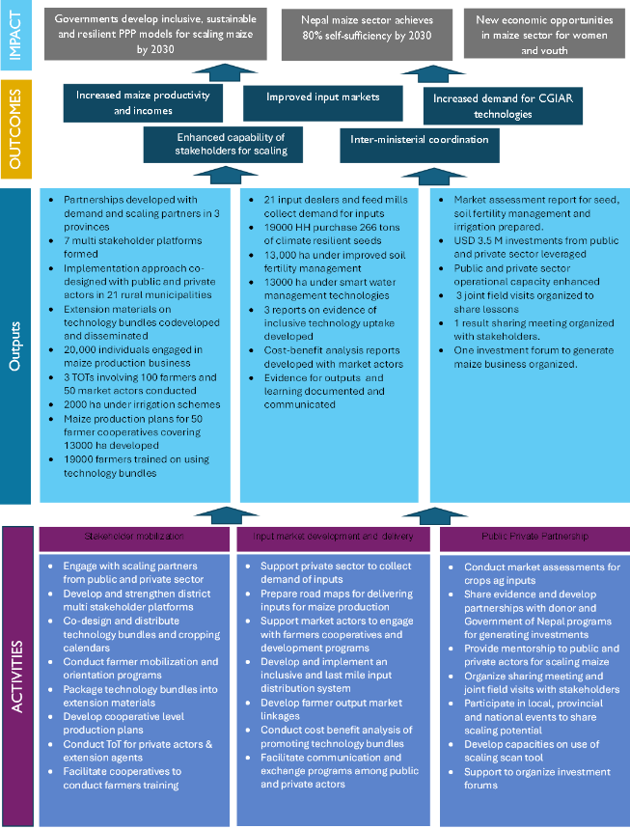
The bundle proposed is extremely complex, likely to involve many different public and private actors - this increases transaction costs. Can less important parts of the bundle be dropped to focus on those that are easiest to scale and that will have most return on investment?
We agree with the suggestions, and we will prioritize maize commercial model as the only crop in this track. Details of MCM innovation is in the link below.
Maize Sector Innovations 2025 Dec 23.docx
The bundles will include seeds, soil fertility management, irrigation, and multi stakeholder platforms. We will drop actors and programs on rice, legumes, and vegetables to make the process more efficient, less complex and impactful.
What business information is there for the profitability of bundle interventions, esp. compost, for example, to drive its use among farmers?
We will conduct cost benefit analysis using the proposed technology bundles in the 2026 season. Our experience shows that improved market linkages, better communication and access to technical information, efficient value chain coordination mechanisms through mentoring, training and exposure and increasing prices are leading to the uptake of technology bundles. The bundles are promoted through best management practices jointly developed with the Nepal Agricultural Research Council (NARC) and are delivered via TOT trainings and digital advisories. We have the following information on the changes in applying technologies over the years:
- The introduction of seed drills reduced sowing costs from US $53 to $26 per hectare.
- About 70% of farmers were using hybrid seeds and 87% practicing line planting for better efficiency and maize plant population.
- About 80% farmers apply urea in V6 and V10 stages for maximum efficiency
- Best management practices, such as targeted urea application and block production, led to a 15% reduction in production costs and improved climate resilience.
- The yield of maize increased to 6.5 t/ha from 3.5 t/ha in 2020 using best management practices.
- The average price of maize/kg increased by 76% from NPR 21 in 2020 to NPR 37 in 2025
- Results show that farmers earn a gross margin of 61% from producing maize.
- Average HH income from maize increased from USD 317 in 2021 to USD 387 in 2025
How much info on costs and benefits was co-generated with the private sector and how and where is the private sector co-investing most in terms of the innovations in the bundle?
We have not done a cost-benefit analysis with the private sector providing input services. This is planned in 2026 to support private sector business development services for input sales to farmers. However, we have done mapping exercises and developed strategies for which private sectors to mobilize in each location.
What other CGIAR programs can you more effectively link with to enhance outcomes? other Programs are listed, but is there a concrete linkage to them - for example, what is the corresponding and specific Breeding for Tomorrow workplan activity that supports this work
We were expecting activities from the Sustainable Farming Science program in Nepal, but there are no activities planned in 2026. In relation to the Breeding for Tomorrow (B4T), the track will highlight the needs for varietal improvement especially in terms of early maturing and heat tolerance, so that the varieties could be introduced and tested in Nepal for seed companies to produce and sell in the near future. We will also collaborate with the seed scaling partners (seed companies, cooperatives, agro dealers) of B4T to deliver quality hybrid maize seeds to farmers, thereby improving their business models.
Specifically, what incentives are you creating among the scaling partners? There are many scaling partners - this also increases transaction costs. Which are most important to focus on and can you drop some and focus on the most crucial ones?
We agree with the observation. As mentioned earlier, we will only work with the demand and scaling partners working on maize. We learned from 2025 that demand and scaling actors have interest and on-going program to scale up agri-input use, but they have limited capability to implement the programs effectively and efficiently due to limited technical know-how. Government entities, Feed mills as Lead firms and input dealers will be the main scaling partners and will be motivated to receive validated technologies, market intelligence, delivery pathways, and mentorship that will add value to their business growth, support to implement existing programs and also to design new projects for 2026-27. CIMMYT has already supported the MoALD to design and fund a new program on input services provision under the maize commercial model which will be continued in 2026. Feed mills are developing sourcing and bundled services for maize producers in collaboration with CIMMYT.
What risks do you anticipate with the upcoming elections and how are you planning for and working to avoid risks that election disruptions may bring? What risk is there to interruption of subsidy programming?
The elections may not hamper any farmer's commercial activity. The Government may have to stop community mobilization activities during the code of conduct enforcement period before elections. However, Governments will be free to implement their approved programs, and we do not see any change in approved subsidy programs.
One of the key questions we asked in the PPT template was not really adequately addressed: How do you know the chosen scaling pathway is the best one? What evidence do you have that an alternative approach may not be better suited to this challenge?
The below write up was written in the solution track document that was submitted for review. It was not possible to cover during the ppt due to shortage of time. Please review and provide feedback.
Farmers receive inputs and services from multiple sources. The scaling pathway proposed in this track includes a public private and community partnership approach. Technology bundles are supported by improved market mechanisms, supportive policies and market governance mechanisms to support upgrading of crop market systems. The approach has been tested and improved since 2021 as it creates incentives for the chain actors to increase investment, adopt new business process, co-create new business model to be competitive in the market and enhance business sustainability. The pathway has shown considerable progress in terms of spring maize growing farmers households increasing by 700% in the pilot phase.
Alternatives:
- Donor money used to purchase inputs for distribution by Government agencies which is highly unsustainable due to lack of a demand pool and market distortion.
- Local Governments disseminating technologies to farmers to boost production often lack private sector participation and often lose pace in providing support as needed by farmers and market actors.
- Private sectors alone may find it expensive and outside their business practice in an evolving market to gather tested technologies for dissemination among farmers and buy-back, without the support of local governments and farmers cooperatives.
We would like to see a more scientifically or business model logic approach to supporting the chosen scaling pathway (which still seems quite complex and a bit unclear to me)
The tracks TOC has been developed and shared above.
Key concern: I think you are trying to do too much with too little budget and too few staff. I strongly suggest dropping least best-bet activities and focusing on the most potentially impactful activities
Yes we have tried to repack the track based on the above suggestions
You target viable business models? Yet this is a VERY complex mode: seeds, irrigation and mechanization X maize, rice, vegetables X Delivery systems, Extension, Last mile, training. I'm not sure what the IT is that you would assess a viable business model of?
Thanks. Our experience shows that market pull approach leads to technology uptake. In 2026, as per the suggestions from the review team, we will only work on maize and drop other crops and mechanization. This will reduce complexity. The following examples of business models will emerge, and we will select the top 1or 2 for this track.
- Agro dealers applying innovative approaches to provide bundled and embedded services to farmers for scaling input use
- The role of inclusive multi stakeholders' platforms in facilitating business development and access to services for scaling production-ensuring including women, youth, Indigenous Peoples, and other marginalized groups—can engage in dialogue, coordination, and joint implementation of maize-related scaling activities
- Farmers cooperatives service delivery business models for member farmers to scale production
- Lead firms facilitating vertical and horizontal collaboration among actors to scale production
Do the govt. subsidies, extension, and various roles of municipalities, provinces and MoALD and others have the funding and capacity necessary to scale?
Yes, the programs of three-tire of government (federal, province and local) have addressed the GoN’s vision on the maize sector “competitive, inclusive and sustainable value chain, import substitution by promoting maize sector in Nepal Terai” mentioned in Agriculture Development Strategy and 16th five-year plan. Accordingly, three tiers of government have allocated funding to support maize sector. Government agencies have limited staff and capability to implement activity aligned to market-based approach. To address this issue, we will provide mentorship support to Government agencies to plan and co-create their activities with stakeholders in the multi stakeholder platforms. We will provide market intelligence and planning support to align their program and budgets with farmers and market actor needs.
Also the GANTT chart has a large number of overlapping activities for a small team - it's so comprehensive it is GREAT, but it is also perhaps so ambitious it might not all be achievable, so focus on what is most impactful and focus on that
We have a simplified GANTT chart based on the downsized partnerships and activities.
I was struck that you include inclusive scaling in your impact, however, I didnt see a direct line from your activities, partners, or engagement model which then leads to inclusive scaling.
Thanks. The following section on reaching the last mile was written in the solution track narrative document. We will focus on indicators such as equitable access to inputs, prices, skill development, information etc. for farmers while participating in the commercialization process irrespective of age, caste, class, gender and ethnicity. We will incorporate a responsive scaling approach throughout the interventions.
- Prepare an outline of the cropping calendar by province; make crop specific operations outline for each production areas
- Facilitate inclusive innovation platform meetings for demand and supply assessment (potential area (location & Ha), coops, qty of inputs, suppliers, buyers) focused on the identified technologies on seed, soil fertility and irrigation. The MSP will also be a common platform to discuss the different challenges faced by diverse groups of farmers. Participation of women, youth, Indigenous Peoples, and marginalized farmers will be actively ensured to influence decision-making on technology and service delivery priorities.
- Co-develop package of practices with NARS including gender friendly technologies bundles for dissemination to farmers and stakeholders
- Develop linkages with local and provincial governments for crop production programs and extension.
- Develop cooperative level production plans with various category of famers (including diverse groups of women, youth, marginalized groups) and inclusive technology delivery strategies
- Organize targeted capacity development training programs, virtual calls and provide digital advisories for extension workers, lead farmers and facilitate follow up trainings; with intentional outreach to women and marginalized groups and adaptive formats to overcome participation barriers.
- Monitor technology use through local governments, local colleges, market actors and cooperatives through physical and virtual means
Give us an assessment of how you think additional scaling team coaching / support could further help you and your team to sharpen the work you will do this year.
We would like to know more of the support that are available. The following support may be considered in the next 3 months:
- Responsible and inclusive scaling
- Return on Investment from scaling maize
- Documenting business models

